МОУ "СОШ №8" г. Губкина Белгородской области

МЕСТО, ГДЕ НАХОДИТСЯ МОЯ ШКОЛА
Автор: Журавлева Лена, 11 класс. Учитель английского языка: Эпова Р.М.

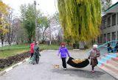
As we become older we realize that there are several essential things and places we always long come back to. They are our birthplace, our home and the school we went to. It is called our small Motherland.

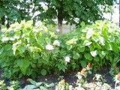
I would like to tell you about my school and the place where it is. We live in the district of Lukyanovka. It is one of the oldest districts in Gubkin. It is far from it. The people live there in their own one – storeyed houses. Their houses are very old but the people are always trying to make their houses better and that’s why our district becomes more beautiful from year to year.
Our school is a two-storeyed building. It is nearly 100 years old. It was founded in 1914. At first it was a small wooden building. All inhabitants of the settlement of Lukyanovka took part in the construction of the school. They brought wood from the Tominov's urotshisha with the help of their horses. The first teacher of our school was P.M. Korshikov. He planted a lot of trees around it and these trees we can see now on the old area of the school.
I should say that our school is rich in its history.
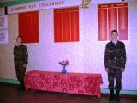
In 1941, from the first days of the Great Patriotic War, the director of our school I.S. Tshesnokov went to the front and gave his life for our Motherland. There is a special stand on the ground floor of our school and we remember all the participants of the Great Patriotic War who defended our native places and did not return from the war. Now their grandsons study at our school. The pupils visit the veterans of the war and they teach us to be honest, brave and love our Motherland as they do it.
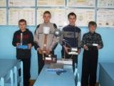
We study six days in a week, our lessons last for 45 minutes and each with 10 or 15 minutes breaks between them. We seldom go home after classes, as a
rule we stay at school for out-of-class activities. Our social and cultural life is well-organized. We have a lot of clubs in our school. The teacher of Physics A.N. Modlin organized a technical club at school and pupils are busy there with creative work. They do a lot of interesting things there and often our pupils take part in the region technical exhibitions and win prizes there.
Sport is an essential part of our school life. Every day we go to the gymnasium or to the sportsground and play games there. Different sports and games are popular with my school friends.
My childhood is happy and I am proud of our school and the place where I live.

